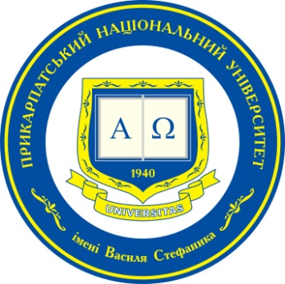 | 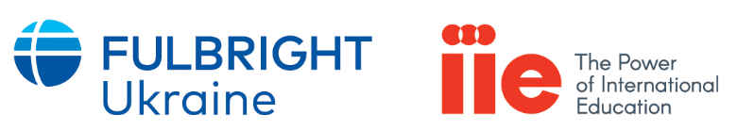

International online conference for young scientists and scholars

Ukraine and the World: Past, Present, Future
(to the 30th Anniversary of the Independence of Ukraine)

Saturday, May 29th, 2021

Topics of Interest and Call for Scientists and Scholar Submissions

The potential participants are invited to prepare a presentation that covers a wide range of issues related to the processes around and within Ukraine, including the following:
- Ukraine in the context of bilateral relations with key international partners.
- Ukraine's cooperation with leading international organizations.
- Ukraine and new challenges at the global, regional and local levels.
- Political system and civil society in independent Ukraine: evolution, current state and prospects.
- Reforms and tackling corruption as a litmus test for the development of Ukrainian society.

- Other related topics are welcome.

Conference language: English

A compendium will be prepared based on the results of the conference. Deadline for submission of the articles and theses of articles for printing: July 15, 2021.

APPLICATION FORM
For participation
in International conference for young scientists and scholars:
Ukraine and the World (to the 30th Anniversary of the Independence of Ukraine)

May 29th, 2021

Participant’s Name and Surname: …….………………………………………

Institutional Affiliation: ..…………………………………………………………

Position in Home Institution: ..…………………………………………………

Presentation Title: ...….……………….………………………………………….
or
Participation in the discussion only…………………………………………

Telephone: .…………………………………………………………………………

E-mail: ……………………………………………………………………………….

Application Deadline: May 10th, 2021
Ihor Hurak
tel. (+38 097) 159 91 97
e-mail: ihorhurak@gmail.com

