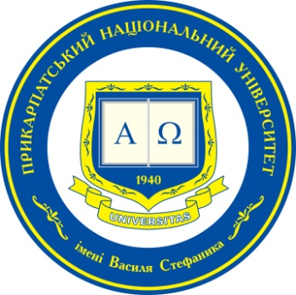

International conference for young scientists and scholars

NATO: Looking for Answers to Current Challenges and Threats

Thursday, November 8th, 2018
Ivano-Frankivsk, Ukraine

Venue: Vasyl Stefanyk Precarpathian National University
(Shevchenka Str. 79, Ivano-Frankivsk, Ukraine)

Topics of Interest and Call for Submissions

The authors are invited to prepare a presentation that cover wide range of issues connected with North Atlantic Treaty Organization, including the following areas:

- NATO on the eve of the 70th anniversary: factors of success and popularity;
- achievements and losses of Ukraine’s neighbors after their accession to NATO;
- Ukraine on the its way to NATO: internal and external threats;
- challenges for the North Atlantic Alliance as a result of differences between the United States and European allies because of issues related to defense spending, trade, climate change and a nuclear agreement with Iran;
- NATO transformation in the context of aggressive foreign policy of Russian Federation;
- NATO in a new security environment: threats caused by the proliferation of mass destruction weapons, international terrorism, cyber attacks, etc;
- Other related topics are welcome.

Conference language: English

Fees, accommodation, travel
- There is no registration fee.
- Accommodation will be covered by the organizing committee accommodation for visiting participants.
- Participants are expected to cover their travel fees.
APPLICATION FORM

For participation
in International conference for young scientists and scholars:
NATO: Looking for Answers to Current Challenges and Threats
November 8th, 2018

Participant’s Name and Surname: …….………………………………………

Institutional Affiliation: ..…………………………………………………………

Position in Home Institution: ..…………………………………………………

Proposed Title of Presentation: ...….……………….…………………………

Telephone: .…………………………………………………………………………

E-mail Address: ……………………………………………………………………

Information on Accommodation (please mark the correct option):
YES – please book accommodation for the November 7th – 9th, 2018
YES – please book accommodation for the November 7th – 8th, 2018
NO – no accommodation

Application Deadline: October 20th, 2018
Ihor Hurak
tel. (+38 097) 159 91 97
e-mail: ihorhurak@gmail.com

